RESULT ANALYSIS
PHYSICS DEPARTMENT
JAGIROAD COLLEGE

SESSION: 2017-18
STUDENTS APPEARED IN 6TH SEMESTER EXAMINATION
NAME CGPA
1, Inamul Imran Thakuria 8.4
2. Sagar Newar 8.6
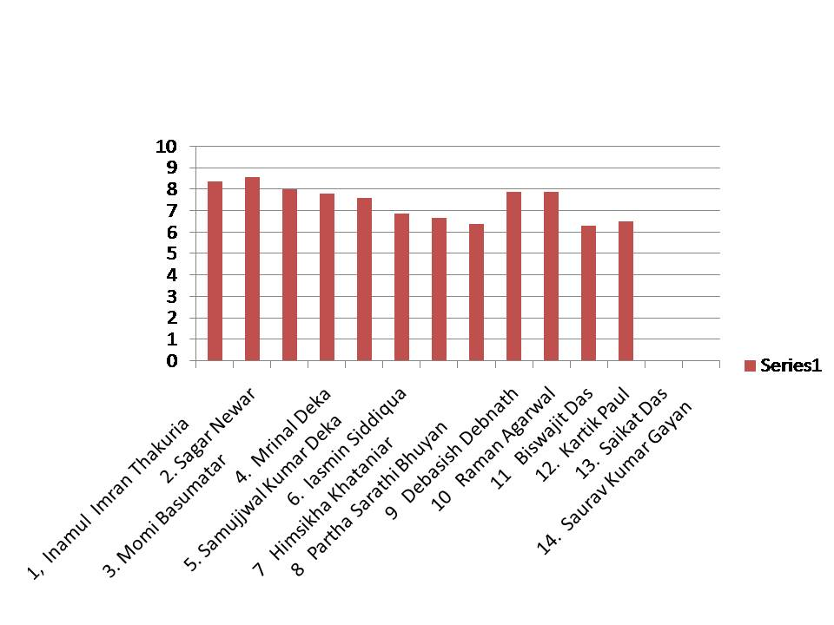
3. Momi Basumatar 8.0
4. Mrinal Deka 7.8
5. Samujjwal Kumar Deka 7.6
6. Iasmin Siddiqua 6.9
7 Himsikha Khataniar 6.7
8 Partha Sarathi Bhuyan 6.4
9 Debasish Debnath 7.9
10 Raman Agarwal 7.9
11 Biswajit Das 6.3
12. Kartik Paul 6.5
13. Saikat Das Failed
14. Saurav Kumar Gayan Failed

Appeared: 14, Passed: 12 Pass Percentage: 85.71%

SESSION: 2018-19
STUDENTS APPEARED IN 6TH SEMESTER EXAMINATION
NAME CGPA
- Dharmeswar Medhi 8.0
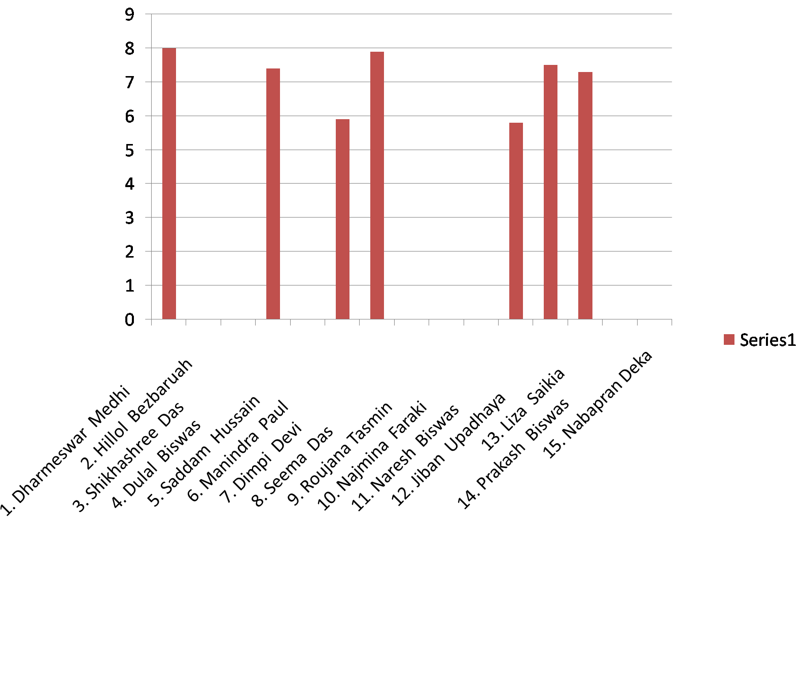
- Hillol Bezbaruah Failed
- Shikhashree Das Failed
- Dulal Biswas 7.4
- Saddam Hussain Failed
- Manindra Paul 5.9
- Dimpi Devi 7.9
- Seema Das Failed
- Roujana Tasmin Failed
- Najmina Faraki Failed
- Naresh Biswas 5.8
- Jiban Upadhaya 7.5
- Liza Saikia 7.3
- Prakash Biswas Failed
15. Nabapran Deka Failed

Appeared: 15, Passed: 7 Pass Percentage: 46.67%

SESSION: 2019-20
STUDENTS APPEARED IN 6TH SEMESTER EXAMINATION

NAME CGPA
- Gopal Debnath 7.86
- Nabajyoti Nath 8.08
- Samujyal Mithi 7.81
- Hirakjyoti Deka 7.71
- Utpal Bharali 7.6
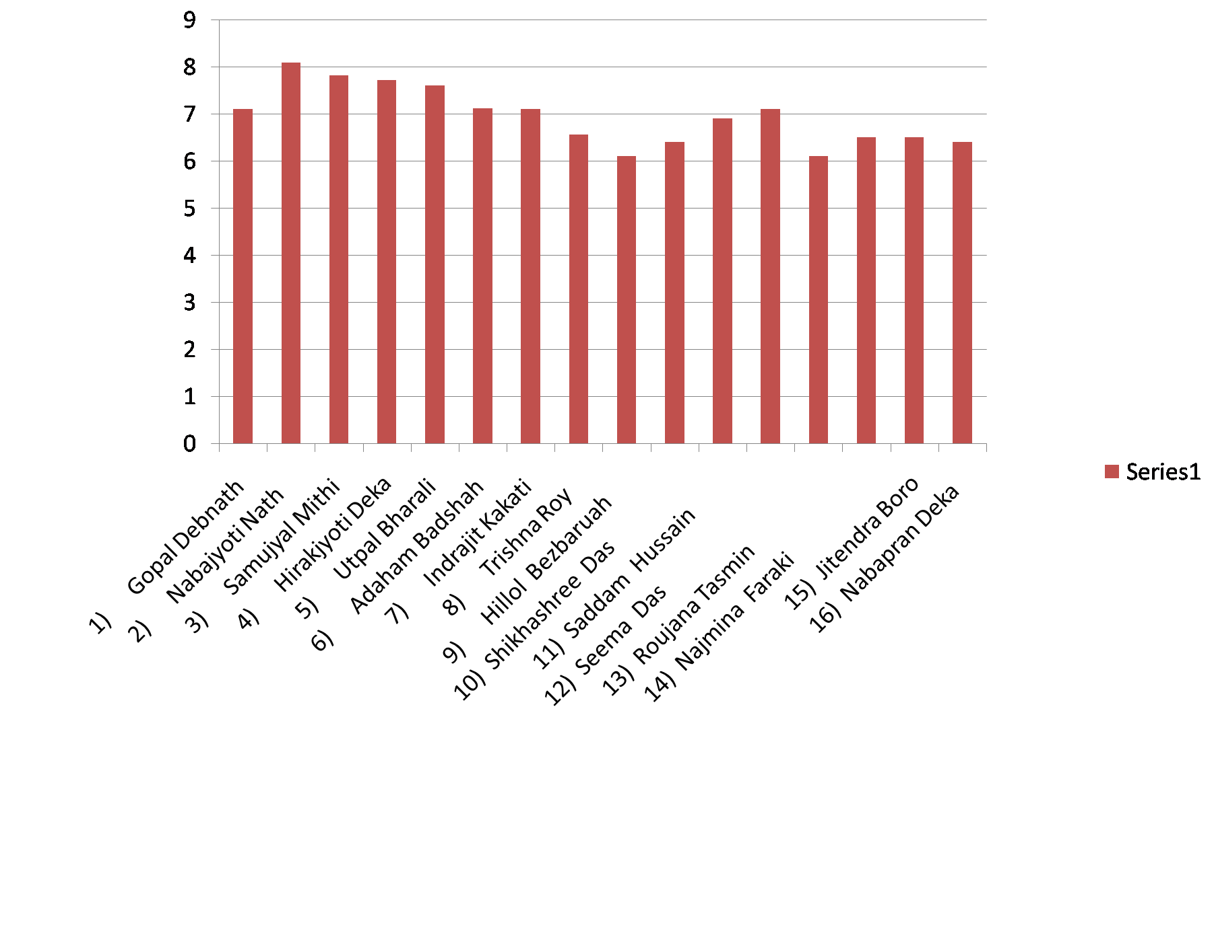
- Adaham Badshah 7.12
- Indrajit Kakati 7.1
- Trishna Roy 6.56
- Hillol Bezbaruah 6.1
- Shikhashree Das 6.4
- Saddam Hussain 5.9
- Seema Das 7.1
- Roujana Tasmin 6.1
- Najmina Faraki 6.5
- Jitendra Boro 6.5
- Nabapran Deka 6.4

Appeared: 16, Passed: 16 Pass Percentage: 100%

SESSION: 2020-21
STUDENTS APPEARED IN 6TH SEMESTER EXAMINATION
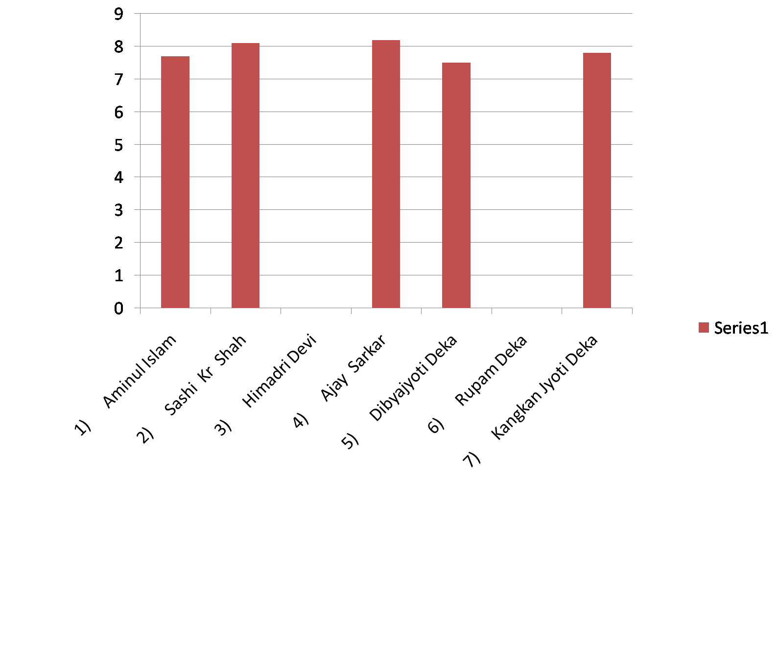
NAME CGPA
- Aminul Islam 7.7
- Sashi Kr Shah 8.1
- Himadri Devi back
- Ajay Sarkar 8.2
- Dibyajyoti Deka 7.5
- Rupam Deka back
- Kangkan Jyoti Deka 7.8

Appeared: 7, Passed: 5 Pass Percentage: 71.4%

SESSION: 2021-22
STUDENTS APPEARED IN 6TH SEMESTER EXAMINATION
NAME CGPA
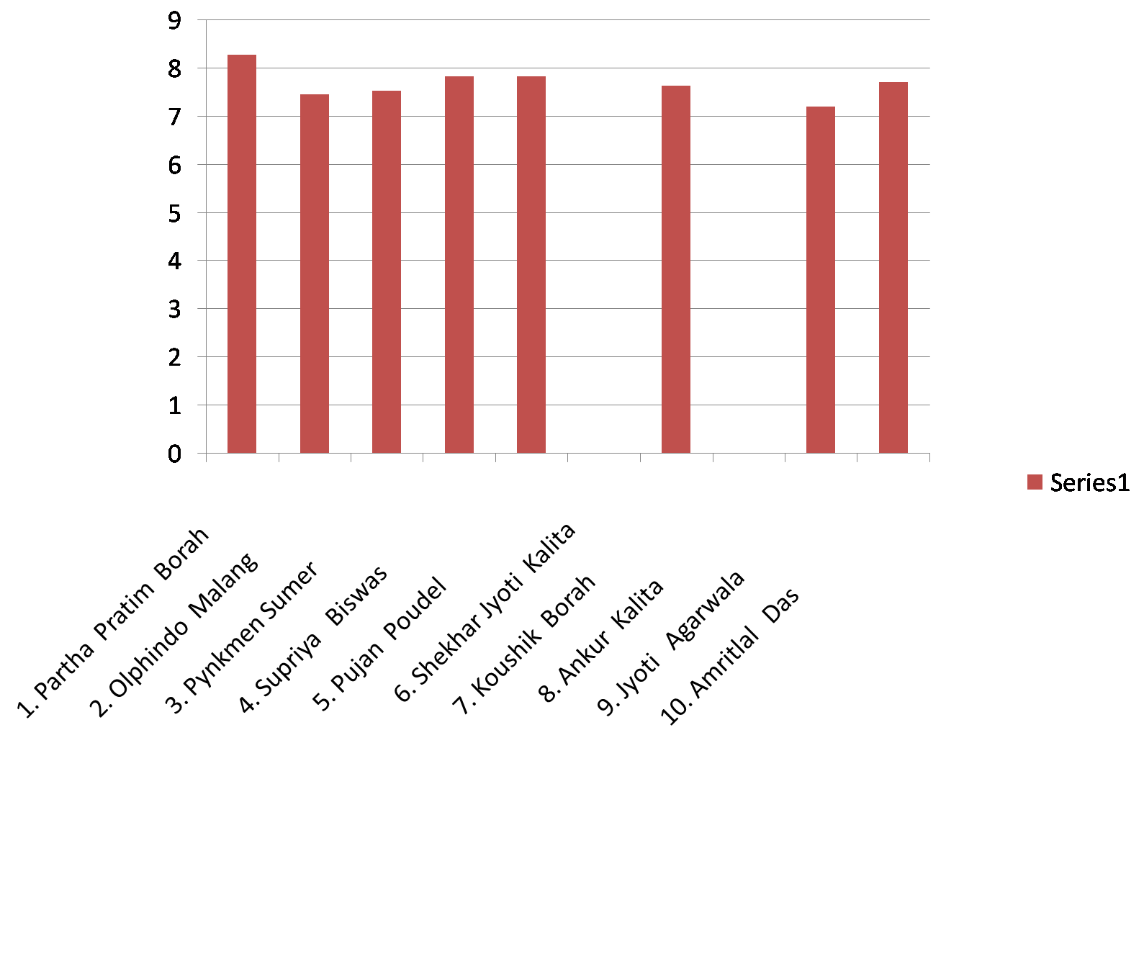
- Partha Pratim Borah 8.28
- Olphindo Malang 7.46
- Pynkmen Sumer 7.53
- Supriya Biswas 7.84
- Pujan Poudel 7.84
- Shekhar Jyoti Kalita Back
- Koushik Borah 7.64
- Ankur Kalita Back
- Jyoti Agarwala 7.2
- Amritlal Das 7.72

Appeared: 10, Passed: 8 Pass Percentage: 80%

Year-wise pass percentage of students
Year | Pass percentage (%)
2017-18 | 85.71
2018-19 | 46.67
2019-20 | 100
2020-21 | 71.4
2021-22 | 80

