SANDHYA HAZARIKA
- Awarded the best Debut Actress in 7th Assam State Film Award for the Film “Nodi Mathu Boi” for the year 2016-17.
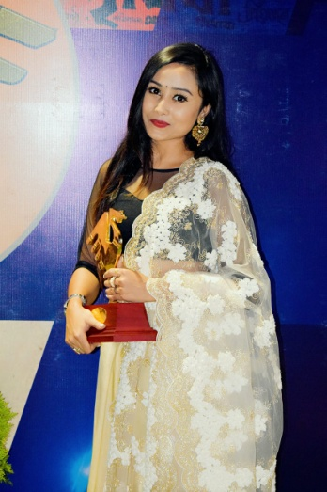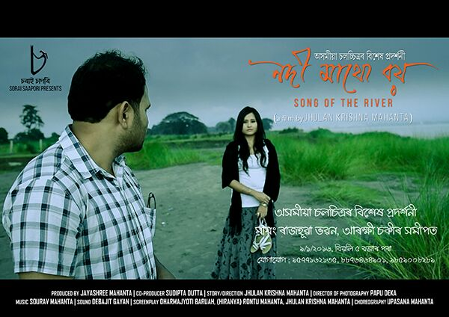
- Performed in many plays with various directors.
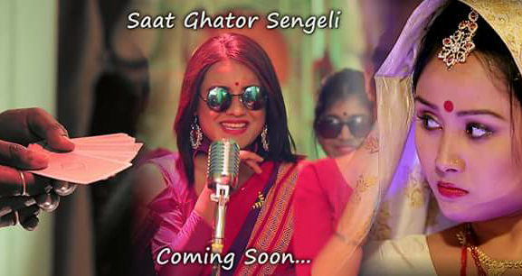
- Performed different indigenous folk dance and Sattriya Nritya in Various National events under Council for Cultural Relation
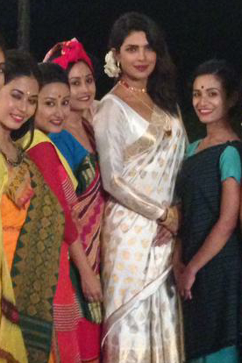
- Working as an Actor in Assamese Film and Televisions including Doordarshan.

