BIJIT KUMAR DAS
- Received Young Talent Artist Award in The field of Mime, NEZCC for the year of 2015-16
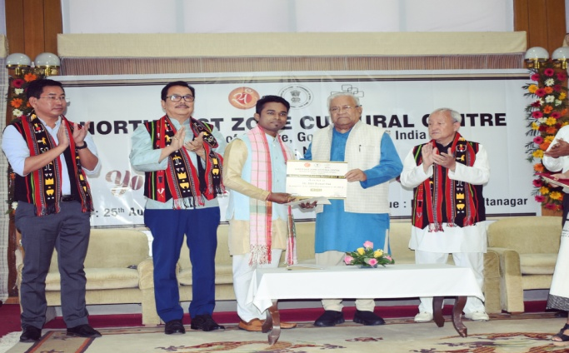
- Pursuing in M.A. in Performing Art under Dibrugarh University
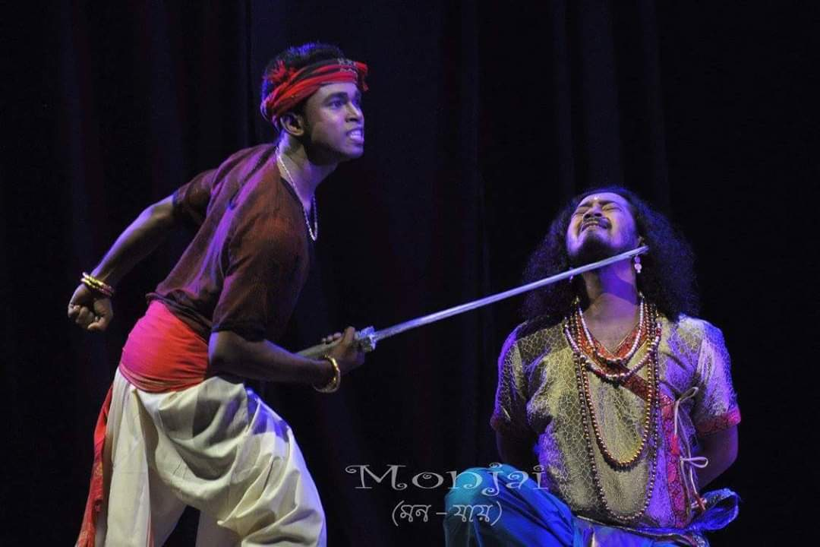
- Received National Senior Scholarship for Young Artist in the field of Mime, Ministry Of Cultural, Govt. of India in 2013
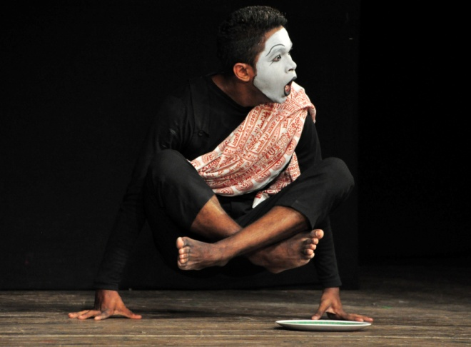
- Participated in many National and International Mime and Theatre festivals with various Director.
