DEBAJIT DEKA
- Received National Senior Scholarship for Young Artist in the field of Mime, Ministry Of Cultural, Govt of India for the year , 2013
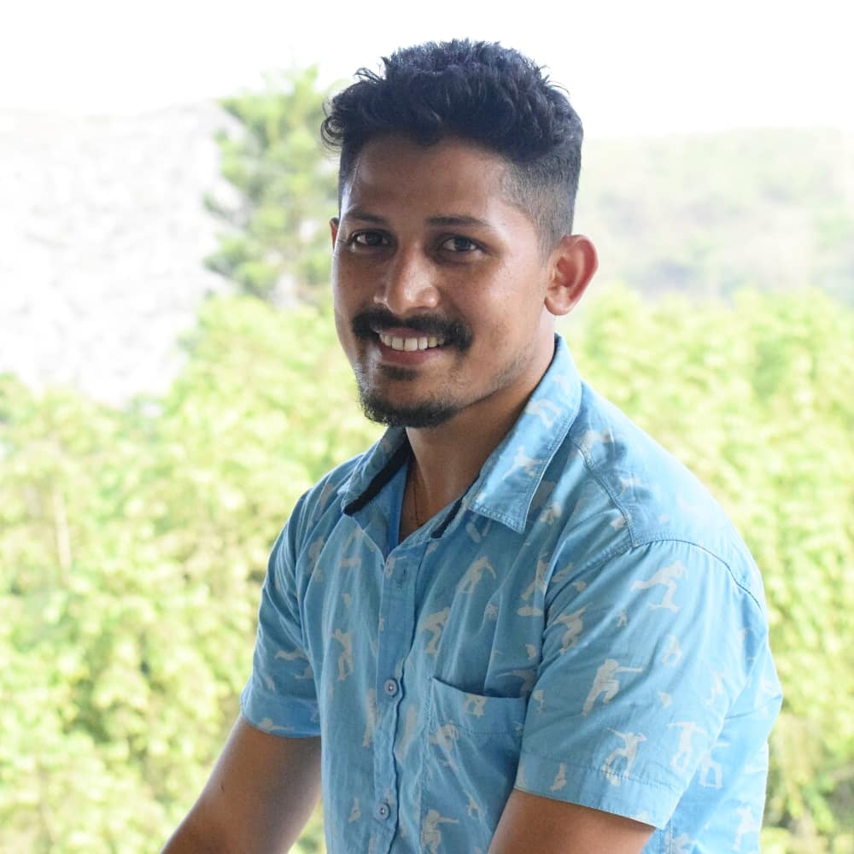
- Performed in many Plays with various director.
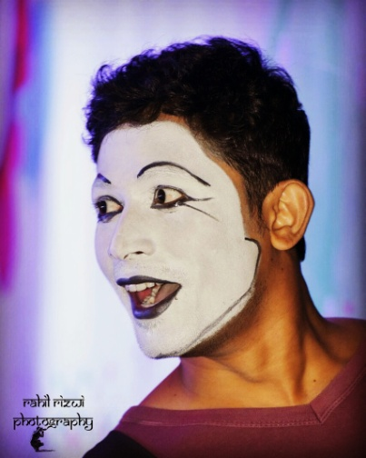
- Working as an actor in various Assamese TV serials and films. Some of them are-
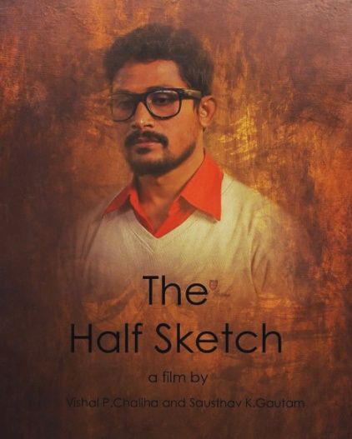
- Chandmarir Chandini in Rengoni Chnnel.
- “The Half Sketch” (Feature Film) Directed by Vishal P Chaliha.
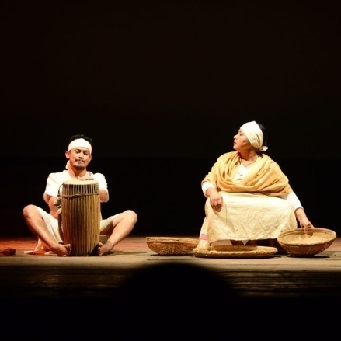
- “A Misinterpreted Malady” and “Okosmat” (Short Films) Directed by Mr. Tarunav Dutta

