PRIYANKA KALITA

- Performed in many plays and Mime Productions with various directors.

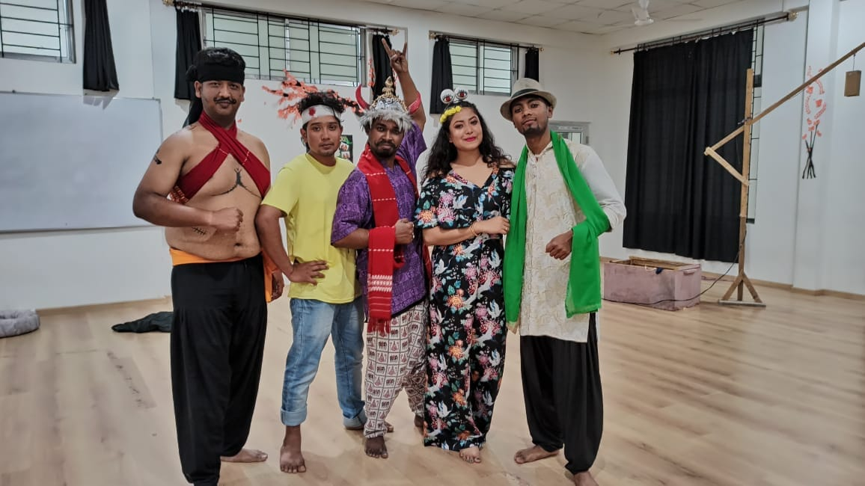

- Working as an actor in TV serials Tele-film for Assamese entertainment channels
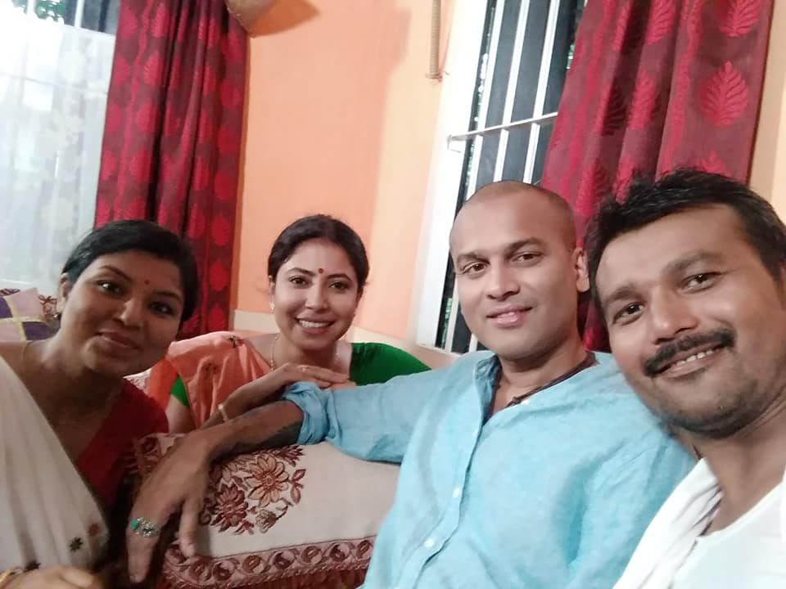
- Winner of 1st State level “Indra Bania Memorial All Assam Mono Acting Competition”

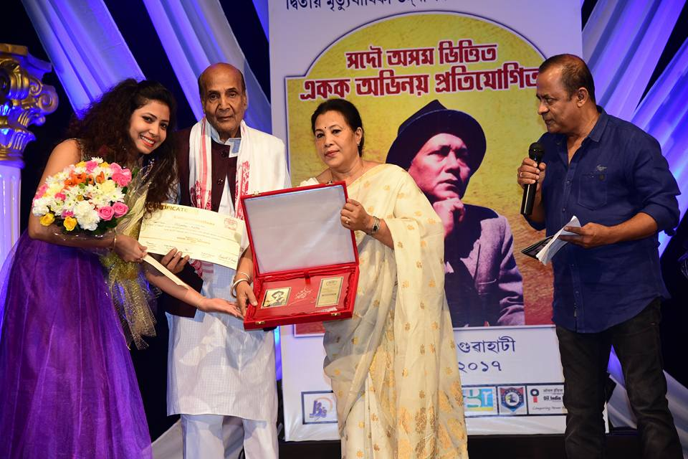

- Winner of Mono Acting Competition in “Coton Mohotsav” 2017
