JYOTISHMAN SHARMA

- Performed in many plays with various directors.
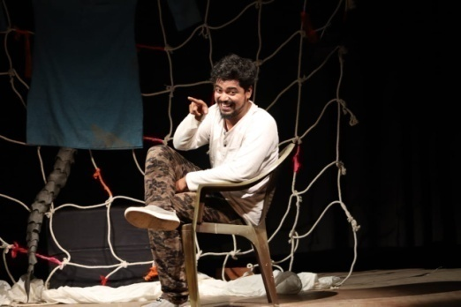
- Directed Children plays.
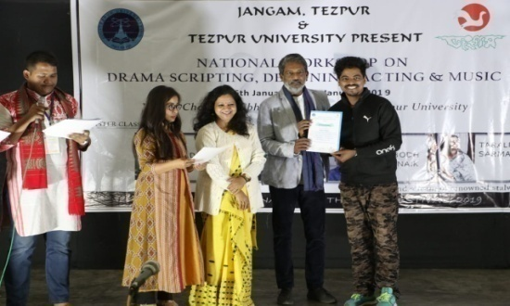

- 3rd position in All Assam Indra Bania Memorial Mono Acting Competion .
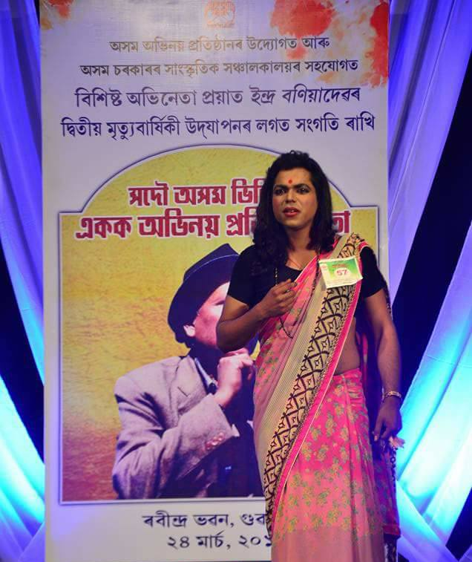

- Working as an actor in TV serials Tele-film for Assamese entertainment channels including DD Kissan.

